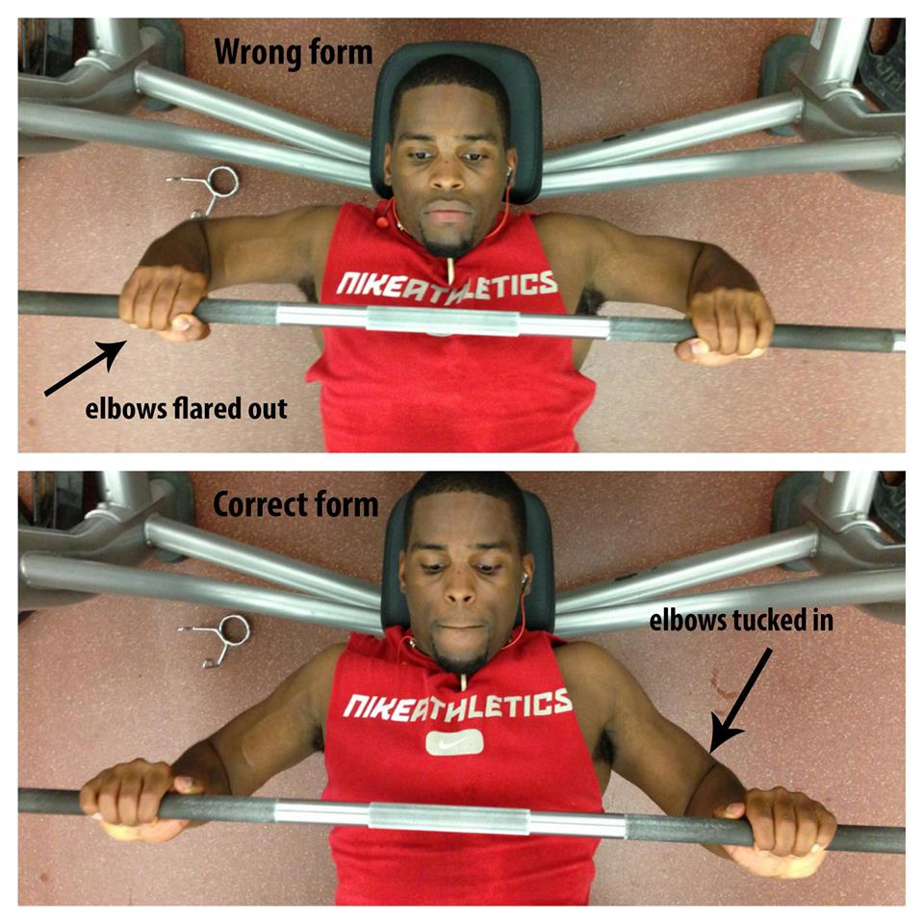

Monday is classically chest day......so here's one of the best tips you'll get to save your shoulders from getting mangled and really stimulate more pectoral development.
Tuck your elbows in, don’t flare them out.
You've been warned.
#getfreaky

